EE-431L: Operating System Lab



Lab Report 01

Submitted to:
Dr. Nauman Ahmed

Submitted by:
Hafiz Muhammad Hunain (2017-EE-16)
Tariq Mehmood (2017-EE-40)

DEPARTMENT OF ELECTRICAL ENGINEERING
UNIVERSITY OF ENGINEERING AND TECHNOLOGY, LAHORE

Exercise # 01:
Understanding the hardware configuration of the working machine using /proc filesystem.
- Processor is the chip including all the cores and various processor peripherals working together to execute instructions of a process. A core is comprised of ALU and registers which are used to execute a single process at a time. So, multiple cores mean multiple processes being executed by the processor concurrently.
- It has 1 core
- It has 1 processor
- Its frequency is 2195 MHz which is approximated as 2.2 GHz

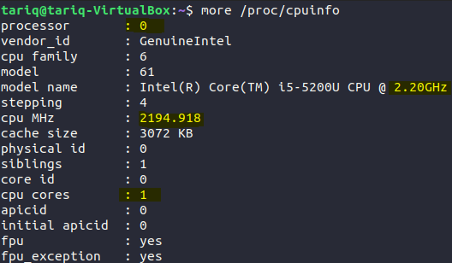

- It has a total of 4030404 kB of physical memory
- Out of which 1662036 kB is free at the moment
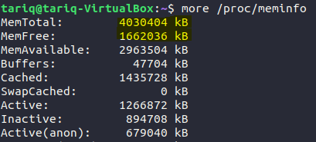
- Total number of number of forks (processes) since the boot in the system is 2657
- Total number of context switches (ctxt) since the boot in the system is 886940
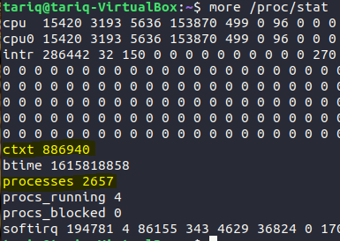
Exercise # 02:
Understanding how to monitor the status of a running process using the top command.
- PID of process running cpu command is 5070
- The process consumes 97.7% of the cpu and 0% of the memory
- The process, at the moment, is in Running state
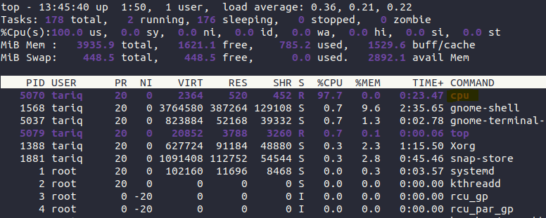
Exercise # 03:
Understanding how the Linux shell runs user commands by spawning new child processes to execute various commands.
- Using -A flag with ps command shows all the process and we can see from the figure PID assigned to cpu-print process is 3062

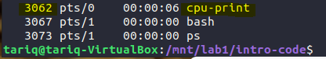

- The process tree of cpu-print is shown by using command pstree -s -p [pid]. Where [pid] is the process id of cpu-print. The -s flag displays parent process and -p flag displays pid shown in parenthesis after each process.

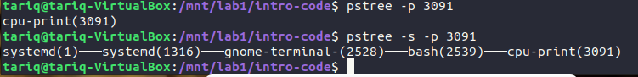
- Using the command “./cpu-print > /temp/temp.txt &” we have redirected the output to a temporary file named temp.txt rather than displaying on a screen.

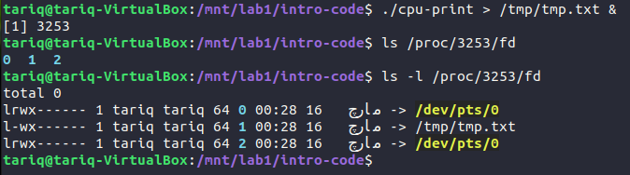
- The Pipe is a command in Linux that lets you use two or more commands such that output of one command serves as input to the next. In short, the output of each process directly as input to the next one like a pipeline. The symbol '|' denotes a pipe. Here from the figure we can see that the grep command is assigned PID 3273 and its input file descriptor i.e. fd0 is pointed towards a pipe. So, cpu-print writes on one side of the pipe and grep reads from the other side of the pipe hence, creating the pipe between the two process.

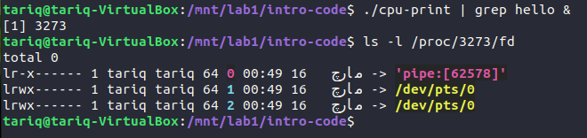

- type command allows us to see if a command is built-in or not.

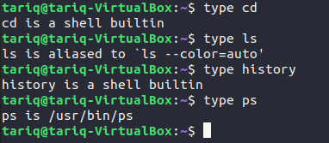

Exercise # 04:
RSS is the Resident Set Size and is used to show how much memory in kB is allocated to that process and is in RAM. It does not include memory that is swapped out. It does include memory from shared libraries as long as the pages from those libraries are actually in memory. It does include all stack and heap memory.
VSZ is the Virtual Memory Size. It includes all memory in kB that the process can access, including memory that is swapped out, memory that is allocated, but not used, and memory that is from shared libraries.
ps -o vsz,rss [pid] command is used to output virtual and resident memory of a process. It can also be viewed using top command.

